BOFEP OCEAN LITERACY WORKING GROUP :
REPORT ON PD DAYS FOR TEACHERS AND EDUCATION STUDENTS

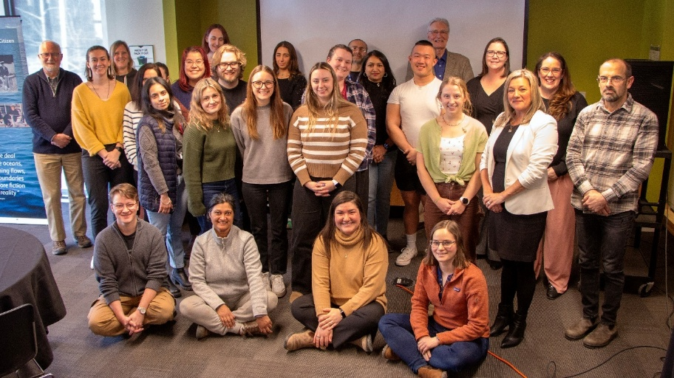
The inaugural professional development days in 2024 were driven by the urgent need to inform and equip teachers to educate the next generation on climate change and the ocean. Given how well they were received – and how pressing the need for ocean literacy continues to be – IOI-Canada held three similar events in 2025. As in 2024, these all focused on The Ocean and Us in an Era of Climate Change and were designed and organised in collaboration with the Nova Scotia Department of Education and Early Childhood Development and the Bay of Fundy Ecosystem Partnership (BoFEP). Two were once again full-day sessions featuring seven specialist speakers – both academics and practitioners – but organised for new target groups. Thus, the first (8th March) was for Acadia University BEd students, held at their request at Dalhousie University, while the second (4th October) was for Cape Breton University BEd students and regional teachers, delivered in Sydney. The third was something of an encore performance based on the success of the March event, with an invitation from Acadia University to present a customised half-day workshop for their education students in Wolfville. Holding events around the province rather than just in Halifax obviously increases the logistical challenges but enables us to reach new audiences and extend the impact of this kind of training. As a result, a total of nearly 100 BEd students and teachers participated this year.

As before, the approach emphasised how participants could actually use the information they were provided with. The schedule, that follows, therefore combined presentations with Q&A sessions as well as demonstration and discussion of related classroom exercises. Additionally, participants all received a specially developed 100+ page teacher guide on “The Ocean and Us in an Era of Climate Change.” Primarily prepared and reviewed by experienced local teachers, with input from IOI and BoFEP, this manual used terminology and teaching protocols familiar within the Nova Scotia educational system. It was also aligned with the provincial science curriculum, while highlighting the connections to multiple courses across the final five years of schooling such as Science, Citizenship, Geography, Career Development, Oceans, Biology and Geology. As a result, participants were equipped with the knowledge and tools to create an important ripple effect among Nova Scotian youth in terms of increased understanding of issues, threats and possible solutions around climate change and the role of the ocean.
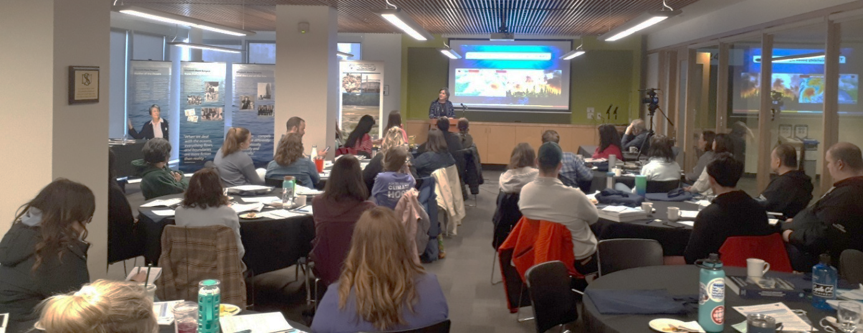

Respectfully submitted by:

Michael J. A. Butler
Chair, Ocean Literacy Working Group.

