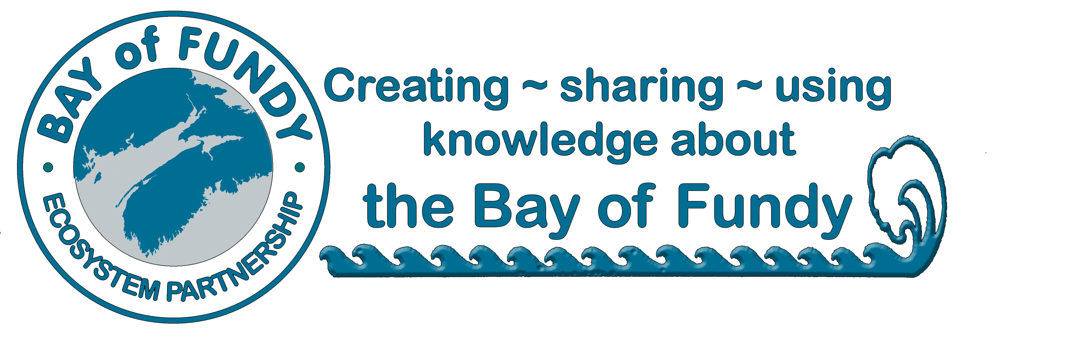
BoFEP
Annual Membership Application

Joining and Supporting the Bay of Fundy Ecosystem Partnership
BoFEP is open to all interested citizens and groups who share its vision for protecting, conserving and sustainably using the Bay of Fundy ecosystem. As a non-profit, volunteer organization, we rely upon donations and membership dues from individuals and organizations to operate our core activities and programs. Members are the heart of our organization!

Benefits of becoming a BoFEP Member include
- Knowing that you are contributing to the efforts to sustain the Bay of Fundy as a healthy, productive ecosystem, including its adjacent coastal communities!
- Receiving the quarterly electronic newsletter Fundy Tidings, which documents new and ongoing activities in and around the Bay.
- Periodic emailing of Fundy Issues Fact Sheets and other BoFEP publications
- Opportunities to participate in and contribute to a variety of BoFEP activities, including our biennial workshop/conference and our working groups that address critical issues of concern.
- Opportunities to join the BoFEP Management and Steering Committees
- Participate and vote at the Annual General Meeting

Membership Categories (Please check one)
􀂉 Individual membership ($25)
􀂉 Organizational membership (e.g. non-profit group, government agency) ($100)
􀂉 I wish to make an additional donation to BoFEP of $__________________

Contact Information

Name ______________________________________________________________________________
Organization ________________________________________________________________________
Mailing address _____________________________________________________________________ Phone _______________________Email ____________________________ Date______________

There are three ways to give:
Visit bit.ly/GiveToBayofFundy to give online securely with Zeffy or snap this code | 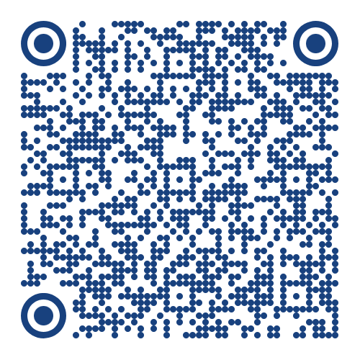
Mail your membership form with a cheque (in Canadian dollars) made payable to
Bay of Fundy Ecosystem Partnership Inc.
P.O Box 29011 | 6960 Mumford Road, Unit 0115
Halifax, NS B3L 4P1

Send dues via e-transfer to BayofFundyEP@gmail.com
(please be sure to email a copy of this application form to the same address)

Membership dues are for the calendar year. A receipt will be issued as soon as your dues are received. Unfortunately, your contributions are currently not tax deductible.

Many thanks for your continued support of BoFEP!

